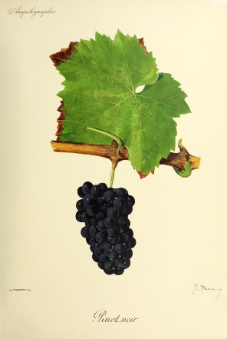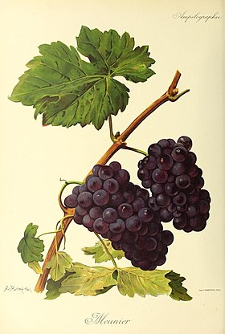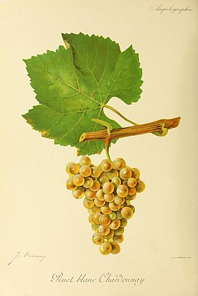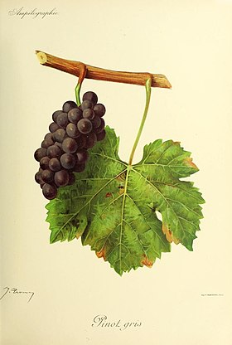

VISIT TO OREGON SEPTEMBER 2022
WINERIES VISITED

- HYLAND ESTATES
. Laurent MONTALIEU Executive winemaker
. Anne SERY Winemaker
. Bruno CORNEAUX Vineyard manager/winemaker

- YOUNGBERG HILL INN AND WINERY
. Wayne BAILEY owner

- HOLLORAN VINEYARD WINES
. Bill HOLLORAN owner

- YAMHILL VALLEY VINEYARDS
. Denis BURGER owner
. Elaine McCALL

- DOMAINE SERENE

- STOLLER FAMILY ESTATE
. Gary MORTENSEN President

- SOKOL BLOSSER WINERY
. Susan SOKOL BLOSSER owner

- TERRA VINA VINEYARDS
. Carole and Karl DINGER owners

